Response to Reviewers Comments

Dear Prof. Su, Dear Editor and Reviewers,

Thank you for offering us an opportunity to improve the quality of our submitted manuscript (EMS20240023). First of all, we would like to thank all reviewers for their constructive criticism, relevant remarks, and interesting questions.

We apologize that the paper contains a few inaccurate statements as pointed out the reviewers. In the revised manuscript, we took those comments seriously and have carefully revised the paper, as indicated in red color.

In the following, we provide responses to all comments raised by the referees and list out all the changes implemented in the revised paper. Thanks again for handling our manuscript.

Yours Sincerely,

Prof. Yuntian Chen on behalf of all the authors

School of Optical and Electronic Information,

Huazhong University of Science and Technology,

Luoyu Road, 1037

Wuhan, 430074,

China

**Reviewer #1**

**Comments 1:** The division of domains for PBF and BBF in this manuscript is a critical step, affecting the accuracy and efficiency of the algorithm. In Figures 5 and 8, it appears that the subdomains are divided manually. Is there a theoretical basis for dividing the domains differently? How can we ensure the divisions are appropriate? Is it possible to automate the division?

**Response:** We thank the reviewer for this relevant remark. The theoretical basis of dividing subdomains in this study is determined by the behavior of light wave propagation. Explicitly, BBF is employed in the domains where the diffraction is insignificant, i.e., only the zero-order diffraction beam dominates the wave propagation, which is also the major assumption or limitation of BBF. As a complementary solution, we incorporate the PBF to compromise our algorithm to cover the rest subdomains, wherein the high diffraction order waves are not negligible. Currently, the subdomains are indeed divided manually. Although automated division is presently unavailable, methods for automatic subdomain division based on optical characteristics and ray tracing method are currently under research.

**Action**: We add the theoretical basis of dividing subdomains in Section Ⅱ.2

**Comments 2:** In the waveguide as shown in Figure 1, the light rays have multiple transmission directions, whereas in the example provided in this paper, PBF can only handle a single transmission direction. Can the technique presented in this paper be used for light transmission simulations in waveguides for AR?

**Response:** Thanks for the comment. The proposed method can be applied to simulate the light transmission in AR waveguides. As shown in Figure S1, one approach is to divide the AR waveguide into transmission subdomains and reflection subdomains, employing BBF and PBF respectively for calculations. This article serves as a proof of concept, and more detailed research will be conducted in the future.

**Action**: No specific action to this comment.

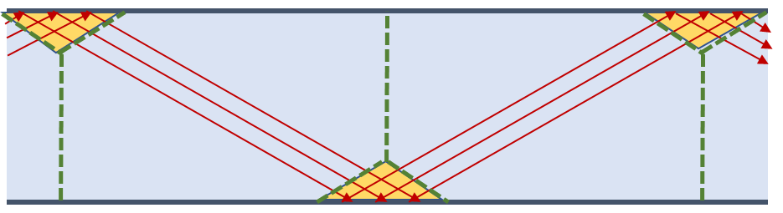

Figure S1. AR waveguide and the simulation method.

**Comments 3:** Figure 9 shows the calculated wave aberration and phase, but optical design usually requires the analysis of optical aberrations. The method proposed in this manuscript belongs to wave optics algorithms. How can the simulation results be used for optical aberration analysis?

**Response:** We thank the reviewer for this interesting question. Indeed, the scope of this paper is to deal with the algorithm of wave propagation in multi-scale domains and can be related to the optical design where the optical aberrations can be exceptionally important. Nevertheless, the detailed procedure of relating our algorithm to optical aberrations in optical design is doable, yet out of the scope of this paper. Since we know all the information of wave propagation, thus the wavefront at any position can be extracted. By setting spherical wavefront as a reference, we can calculate the Zernike coefficients up to arbitrary order, which can further be related to the optical aberrations for comprehensive optical design.

**Action**: We add the method for optical aberration analysis correspondingly in the Section Ⅱ.4.

**Comments 4:** The authors pointed out that conventional iterative solving methods do not converge, but the reasons are not clearly explained. Additionally, why does this damped block Jacobi iterative method work? This iterative method is not a common one.

**Response:** We thank the reviewer for your kind suggestion. The traditional iterative solution method fails to converge due to the introduction of a phase factor of BBF, which deteriorates the state of the system matrix, causing a loss of its symmetric positive definiteness. The damped block Jacobi iterative method introduces a damping factor that reduces the iteration step size and prevents oscillations, facilitating convergence toward the exact solution.

**Action**: We add the more detailed reason correspondingly in the Chapter Ⅳ.

**Comments 5:** As shown in Figure 2, the author assembles and solves the system matrix using a parallel method. Which parallel framework is adopted, and how is the highest parallel efficiency ensured?

**Response:** Thanks for the comment. The proposed method in this paper utilized the MPI parallel framework. First, the number of meshes and degrees of freedom of subdomains allocated to each process need to be balanced. Second, the MPI_Barrier() function is called during each iteration round to ensure all subdomains are solved before exchanging solutions of neighboring subdomains and proceeding to the next iteration round. The computational time is inversely proportional to the number of decomposed subdomains (N) under the parallel computing configuration, the computational time in our work is approximately reduced to $\frac{1}{3N}$ of that using standard FEM for the two examples.

**Action**: No specific action to this comment.

**Reviewer #2**

**Comments 1:** The adoption of BBF requires strong known conditions, i.e., the wave vector k or the direction of propagation of the wave. Under such condition, is there any interference phenomena allowed in the region? and can the diffracted wave that deviates from the main beam be accurately calculated? Like in Figure 5, how the scattered waves in the G region with different k are calculated accurately?

**Response:** Thank you for your constructive comments. The interference effect between two beams with different directions in the BBF region is currently not allowed, see more details about the limitations of BBF in our reply to comment 1 from Reviewer 1. Indeed, our proposed method can only handle wave propagation with a dominated zero-order diffraction beam, which can be extended to account for the counter-propagation direction beam if necessary. The dominated zero-order diffraction approximation is the major assumption and is also the limitation of our method.

**Action**: We add the discussions on the limitation and the scope of our approach in the Chapter Ⅳ.

**Comments 2:** According to Page4 right line 31-33 , "In contrast, the BBF incorporates a phase factor term to segregate the rapidly oscillating component from the field,", there should be a phase factor term in Equation 4, but it is not found with definition.

**Response:** Thank you for your careful check. In the Eq. (4), $e^{ik⋅r}$ is the phase factor term and the fast-varying envelope term, and $N_{j}(x,y)$ is the slow-varying envelope term.

**Action**: We add the detailed descriptions in the corresponding paragraphs of the revised manuscript.

**Comments 3:** It is recommended to list the limitations and scope of the proposed method. Is it necessary to know in advance the exact direction of propagation of the beam, and to what extent interference and diffraction should be limited in the BBF application region? Also, is the method only suitable for 2D scenario?

To achieve the fastest convergence, it is concluded when the damping factor ω = 2/3. Is it universally applicable, or is it just an example tried out in the paper? What should it be determined for a new iterative calculation?

**Response:** We thank the reviewer for raising this important remark. We apologize that the limitations and the scope of our proposed method are not explicitly stated. The main assumption of our BBF is that the zero-order diffraction beam dominates the wave propagation, thus the existence of high order diffraction beams shall lead to inaccurate numerical results. When only the zero-order diffracted beam is included, as shown in the results of Figure 5 in the manuscript, diffraction can be well calculated, but we do need to know the approximate direction of the power flow of the light wave. Regarding interference, our BBP currently cannot handle two overlapping beams with different directions. This limitation necessitates the inclusion of full-wave FEM calculations when combining BBF-FEM with DDM. In future research, we aim to expand the use of more sophisticated PBF and implement more refined regional divisions to properly address complex diffraction and interference scenarios.

The proposed method is also applicable in 3D scenarios. Similar to 2D cases, there must be a primary direction of beam propagation.

The empirical range for the damping factor $ω$ is $0.5<ω<1$. In the absence of information about the matrix characteristics, $ω=2/3$ or $ω≈0.8$ are commonly used empirical values. When the spectral radius $ρ$ of the matrix is known, the damping factor can be chosen as $ω=\frac{2}{2-ρ}$.

**Action**: We add the discussions on the limitation and the scope of our approach in the Chapter Ⅳ and modify the statement about the damping factor in the Section Ⅱ.4.

**Comments 4:** In the example 1, in C region, there are distribution details that differ from results by FEM, with small scattered parts, as well as in the main beam. However, the details of the G region are quite accurate. According to the causality between C and G, and the fact that errors along the beam are usually cumulatively magnified. why is the deviation in the C region not reflected in the G region?

**Response:** We thank the reviewer for careful reading of our work. The scattered parts in C region are caused by the Fresnel lens reflection in F region, not by accumulation in C region. Additionally, to avoid the accumulation of numerical dispersion errors, we used second-order basis functions, as described in Section II.2. As shown in the Figure S2, it can be observed that the results without F and G regions of our method are consistent with the standard FEM.

**Action**: We add a brief discussion correspondingly in the revised paper.

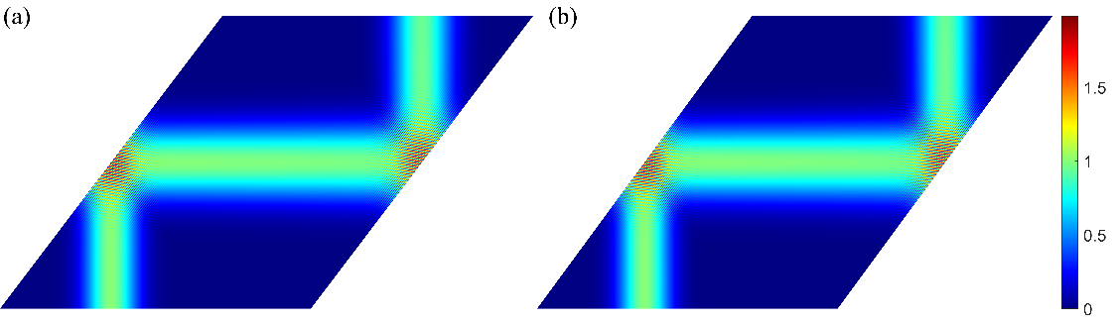

 Figure S2.Electic field intensity without F and G regions. (a) represents the electric field calculated by COMSOL. (b) represents the electric field calculated by DD-BeamFEM.

**Comments 5:** In the example 2, the field distribution of the non-uniform grating structure are not in the displayed region, are they introduced through analytic formula calculation at the boundary?

**Response:** We apologize for the misunderstanding. The optical elements in example 2 only consists of three aspheric reflecting mirrors, without diffraction elements. The aspheric mirror is directly geometrically modeled using Eq.(18). The rim diffraction effects of this free surface optical system are hard to simulate by geometrical optics.

**Action**: No specific action to this comment.

**Comments 6:** The field distribution images in Example 2 appear to be stitched together by image squares, and there are several square boundary pixels that are not perfectly aligned. It should be corrected.

**Response:** Thank you for pointing out the problems. In the example 2, the field distribution is presented as a single image. However, due to its large size, it was compressed during export, resulting in a visual appearance that suggests it is composed of image blocks. This issue has been corrected in the revised manuscript.

**Action**: We correct Fig. 5 and Fig. 8 in the revised paper.

**Reviewer #3**

**Comments 1:** The slowly-envelope approach in Eq. (4) shows a rapidly varying term in the form of exp(ikr), where k is the wavevector in one particular direction. This approach could handle the case of paraxial beam propagation, as is shown in the computational examples in Section III. However, does this approach apply for non-paraxial or even high-NA situations? Or, till what kind of non-paraxiality does the propose method work?

**Response:** Thanks for your rigorous consideration. The proposed method applied for non-paraxial and high-NA situations as long as the beam has a primary propagation direction. As shown in Figure S3, the electric field intensity of a non-paraxial model can be accurately calculated. The direction incident beam forms a 10°angle with the x-axis.

**Action**: We add a brief discussion in Chapter Ⅰ.

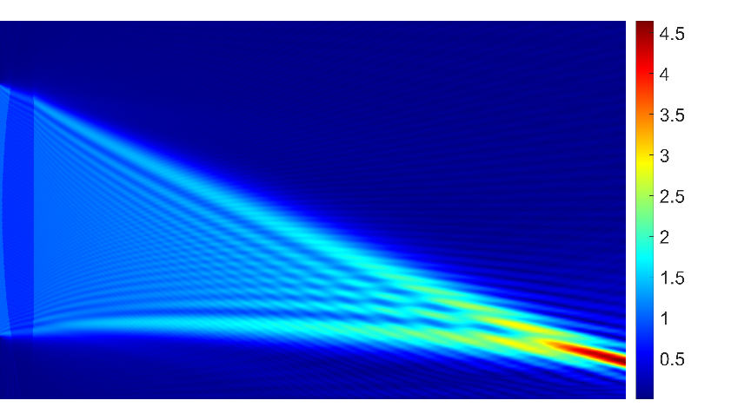

 Figure S3. Electric field intensity of a non-paraxial model.

**Comments 2:** In Section III 1, the authors mentioned x/y-axis more than once. I suggest that those axes shall be marked out in the figure

**Response:** Thank you for your kind suggestion. x/y-axis has been marked out in the Fig. 5 and Fig. 8 in the revised manuscript.

**Action**: We mark out the x/y-axis in the Fig. 5 and Fig. 8 in the revised manuscript.

**Comments 3:** in Section III, the for both examples presented, the spatial distribution of the input beam is not clearly specified. Does the input field show a Gaussian profile? What are the parameters that specifies its profile?

**Response:** Thanks for the comment. The input field shows a Gaussian profile. The expression of the electrical field is $E=e^{-\frac{r^{2}}{ω^{2}}}$, where $ω$ is the beam waist radius at the center. In Example 1, the input beam direction is along the positive y-axis, and the beam waist radius is 6 µm. In Example 2, the input direction forms a 14° angle with the x-axis, and the beam waist radius is 0.14 mm. This has been clarified in the revised manuscript.

**Action**: We add the parameters of input beam correspondingly in the revised paper.

**Comments 4:** In Section III 2, the authors mentioned that the overall dimension of this system (Fig. 8) is approximately 2x2 mm. However the results in Fig. 9 shows that the field distribution at the output port has a lateral distribution over 2 mm. These numbers are inconsistent.

**Response:** We apologize for the misunderstanding. Because of the geometric modeling, the lateral distribution of output port is 0.16mm(-1.3mm~-1.14mm) in Fig. 9. To avoid misunderstanding, we repositioned the system, setting the midpoint of the output port as the origin of the coordinate system and revised Fig. 9.

**Action**: We revise Fig. 9 according to the new coordinate system.

**Comments 5:** The method proposed in this article shall be able to handle the vector-field. However, the authors did not mention any vectorial effect. To demonstrate the capability of the proposed method, I suggest to consider vectorial effects as well.

**Response:** Thanks for your kind suggestion. The proposed method can effectively handle vector-fields, as demonstrated in Chapter II. The specifical calculation depend on the chosen basis functions. In the examples provided, scalar basis functions were used to calculate longitudinal component of the electric field. Using vector basis functions, the method can also calculate transverse component of the electric field.

**Action**: We add a brief discussion correspondingly in the Section Ⅱ.1.